**WEB TECHNOLOGY FINAL SEMESTER PROJECT**

**PUSKESMAS SYSTEM DESIGN**

**RELATED TO PURCHASE OF DRUG AND DOCTOR CONSULTATION**



**By:**

**I Komang Arya Adi Kusuma; 2115101012**

**I Kadek Bayu Danu Artha; 2115101025**

**Kadek Losinanda Prawira; 2115101046**

**Computer Science Study Program**

**Informatics Engineering**

**Engineering and Vocational Faculty**

**UNIVERSITAS PENDIDIKAN GANESHA**

**SINGARAJA**

**2020**

**CHAPTER 1**

**PRELIMINARY**

* 1. **Title**

“Health Centre System Design Related to Medicine Purchase and Doctor Consultation”

* 1. **Background**

In the current era of technological developments, many things have become available on the internet. Like many emerging E-commerce that provides a variety of goods or services. In simple terms, E-commerce itself is the distribution, sale, purchase, and marketing of goods or services by relying on electronic systems, such as the internet, TV, or other technological networks. Many E-commerce also appear in various fields including health, such as Alodokter, Halodoc, Klikdokter and some others. From this, we were inspired to create a website for health agencies to make it easier for people to get health services.

In this case, we chose to create a website for the puskesmas, where this website includes services in the form of buying medicines and consulting with doctors. Previously, there may have been several websites that provided similar services, but most of the consultations were only in the form of online consultations. Meanwhile, this website is in the form of a queue to consult the doctor concerned, so that later the user or patient can consult directly to the puskesmas and meet the doctor. Regarding ordering the medicine itself, it is like a normal purchase where the payment method is COD. This website itself implements Laravel 9 technology.

* 1. **Objective**

Making this website itself has several objectives, namely as follows:

1. Fulfil one of the final project requirements in the Website Technology course.
2. Designing a website in the health sector for purchasing medicines and consulting services to doctors.
3. Development of a health service system in health agencies so that it is easier to consult with doctors by being able to make an appointment with the doctor concerned.
   1. **General Description**

The website that we created ourselves is a system that can help people who want to buy medicine or want to make an appointment with a doctor. With this website itself, it can make it easier for users to get health services because they can make appointments with doctors more easily. In making an appointment with the doctor himself, the doctor can also confirm whether or not he can have a meeting with the patient, besides that it is also related to buying the medicine which is easier because it can be done from home and is more secure.

CHAPTER II

RESULTS AND DISCUSSION

* 1. **User Needs Analysis**

User requirements for this website system itself are as follows:

* 1. The system has an attractive appearance and can be used by users easily.
  2. The system uses icons that match the button functions and are easy to understand.
  3. Search and filter features make it easy to search data.
  4. There is a file management feature in the form of uploading photos of drugs in the form of images.
  5. **System Design**

From the analysis of user needs above, the use cases that can be analyzed are as follows:

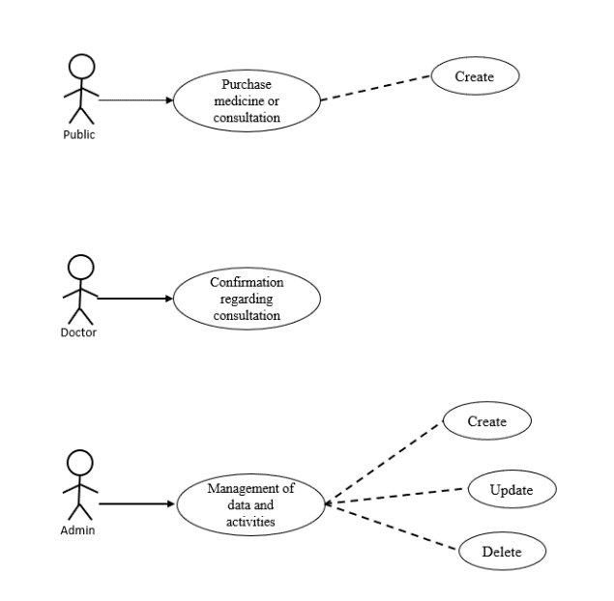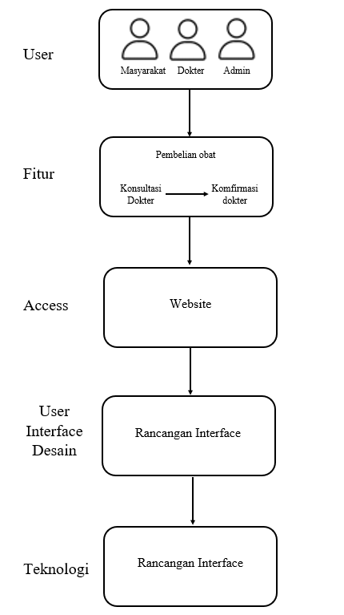

From the picture above there are 3 users in the system later where each user will have their own ability to manage data on the website later. Like the admin who has overall rights to the data in the system, so the admin can do CRUD in the system. Then there is the public where, as a normal user the public can only do CR on the frontpage later. Finally, there is the doctor where the doctor only confirms the agreement made by the user whether he can or not so that the doctor can see all lists of consultation requests by users or the public. From the use case analysis above, a website display design can be made as follows:

1. Backpage

View list of doctors

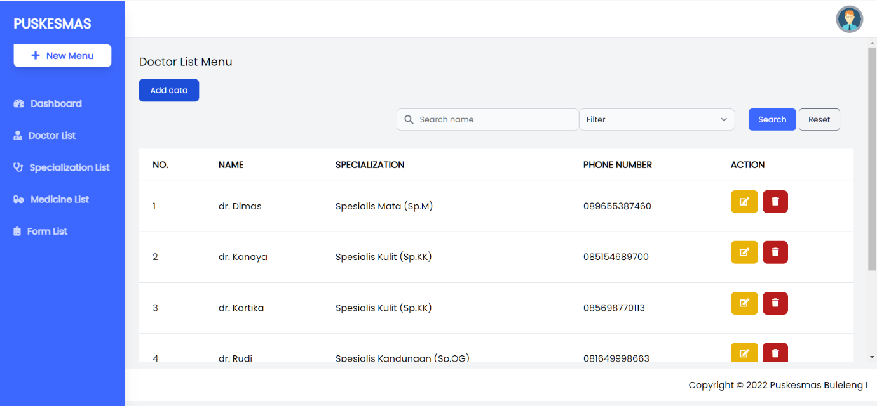

Add new list doctor

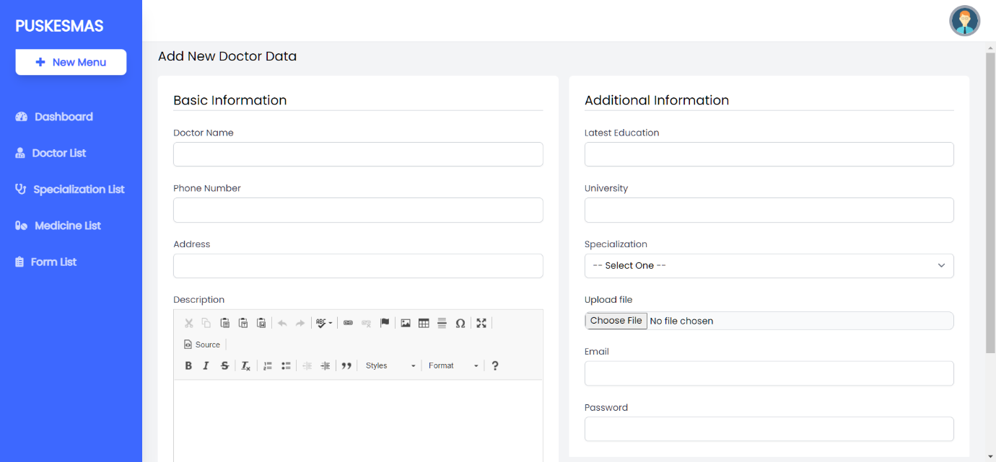

Display medicine list

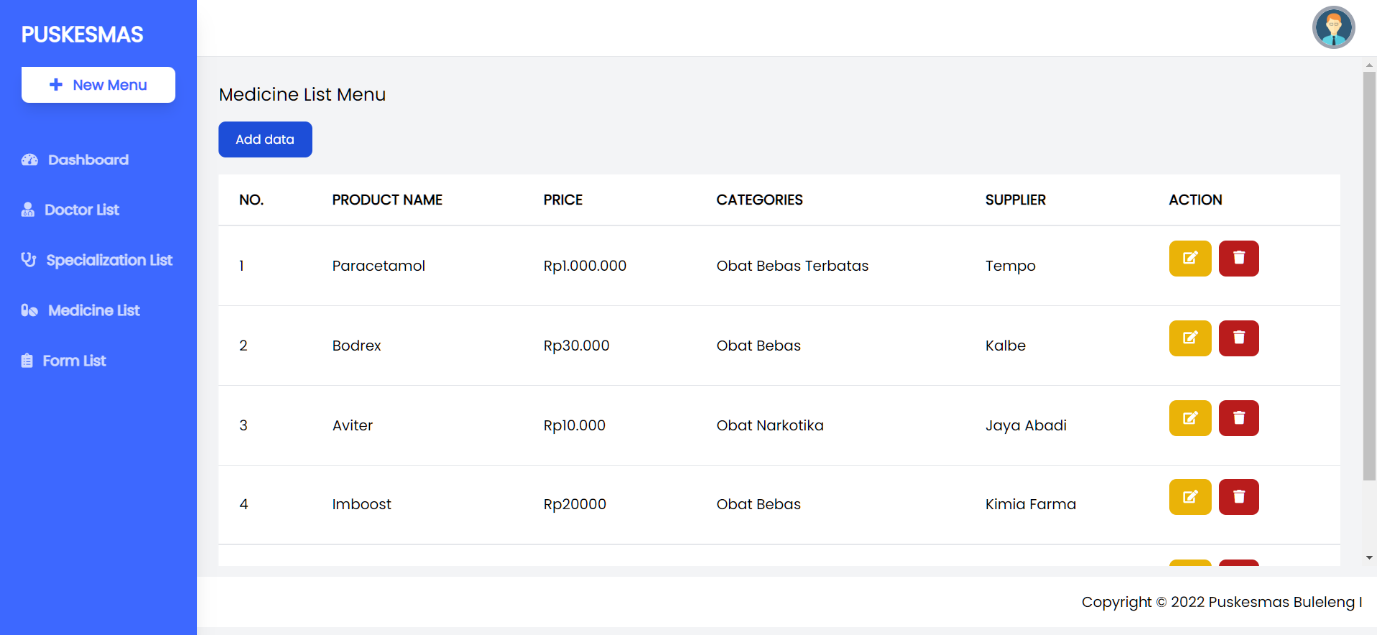

Display adds new medicine data

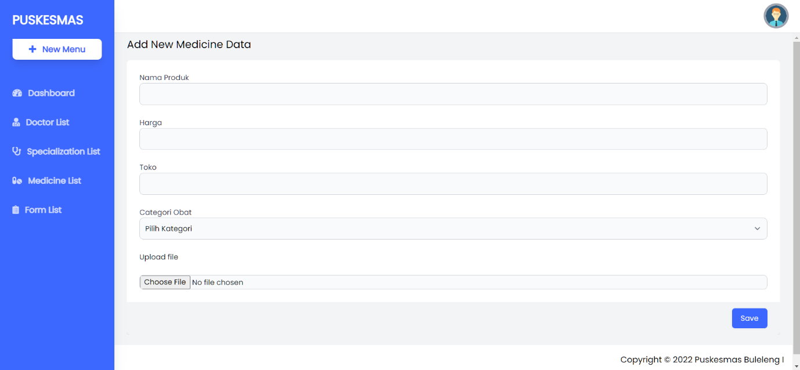

Display form list user

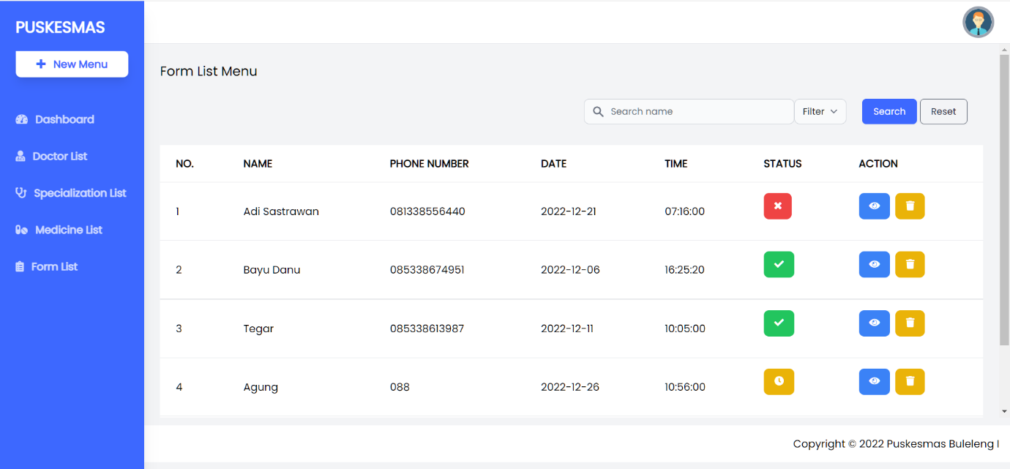

Display edits form list user

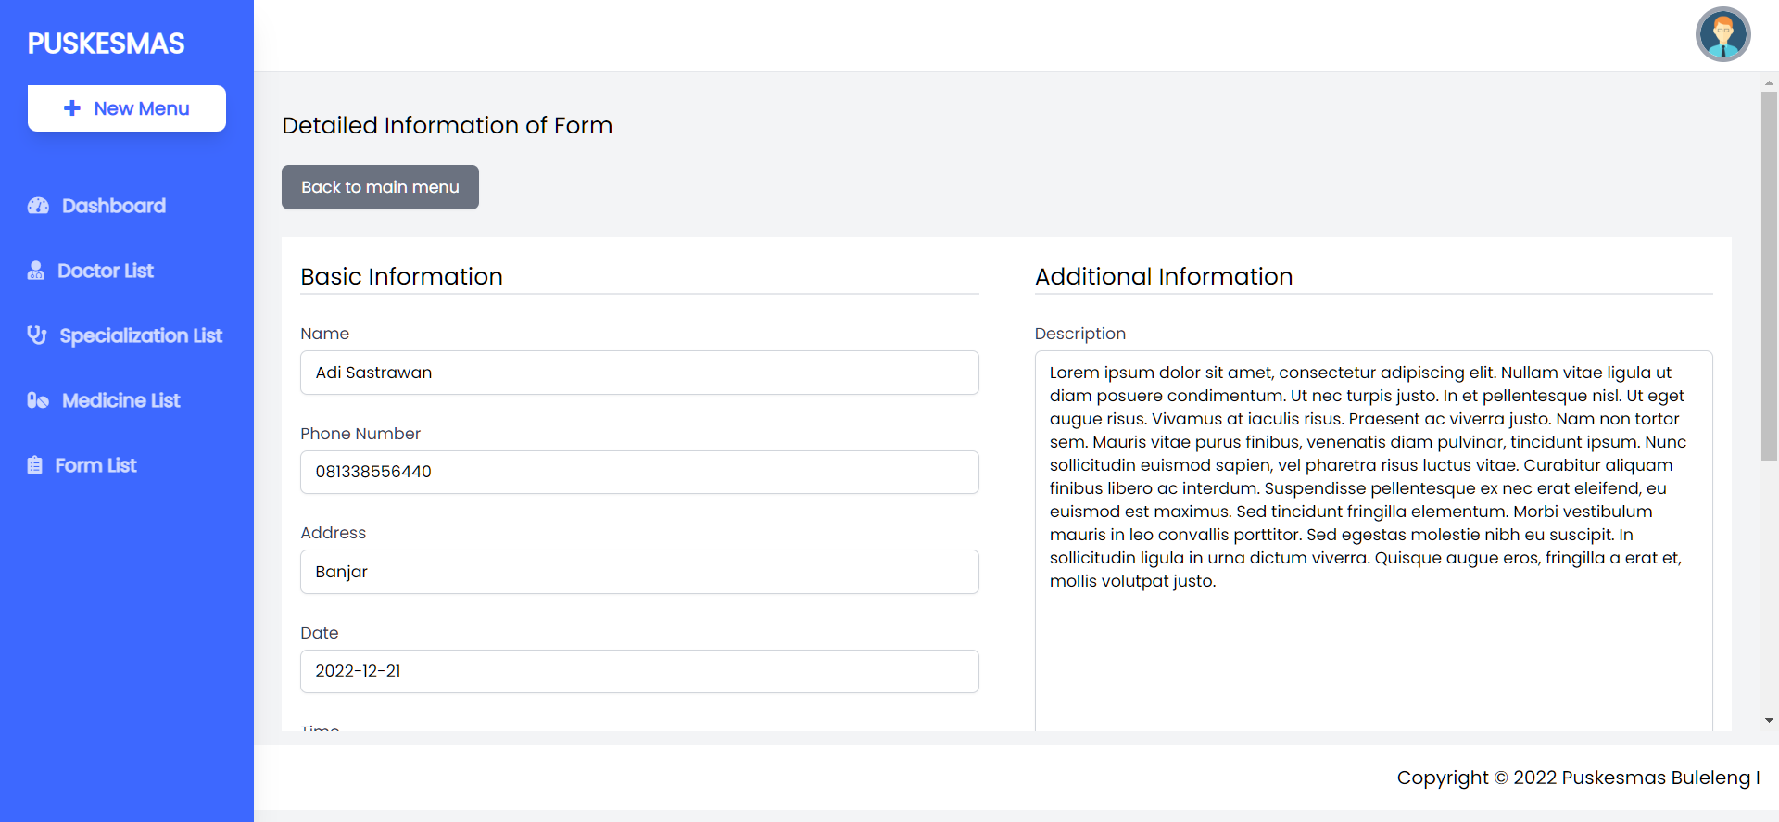

Display specialization doctor list

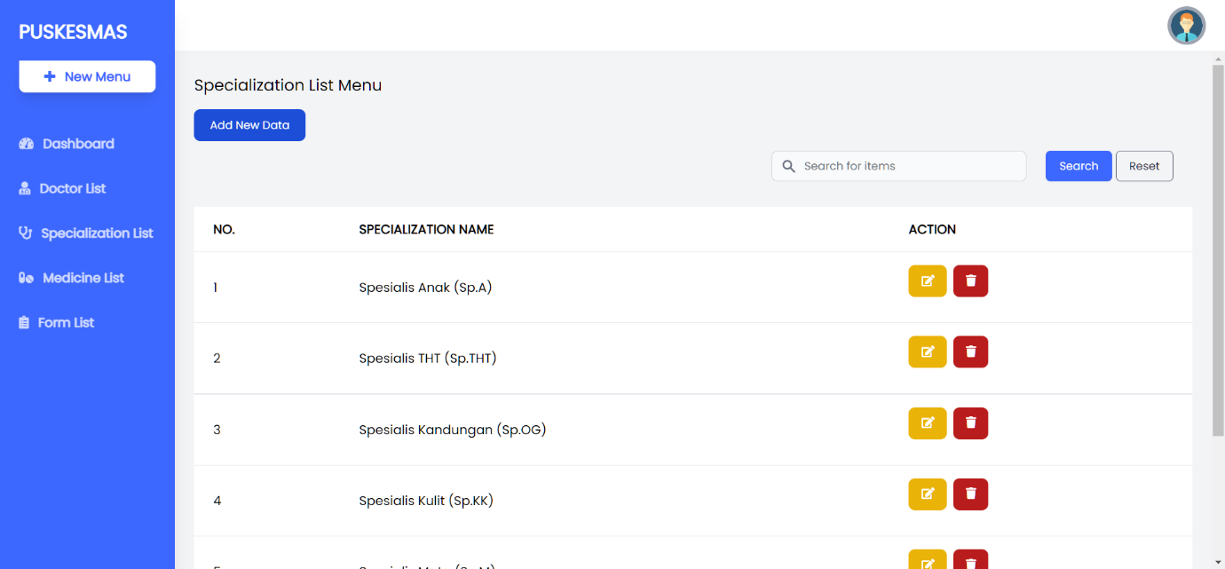

Confirmation edit and create specialization doctor

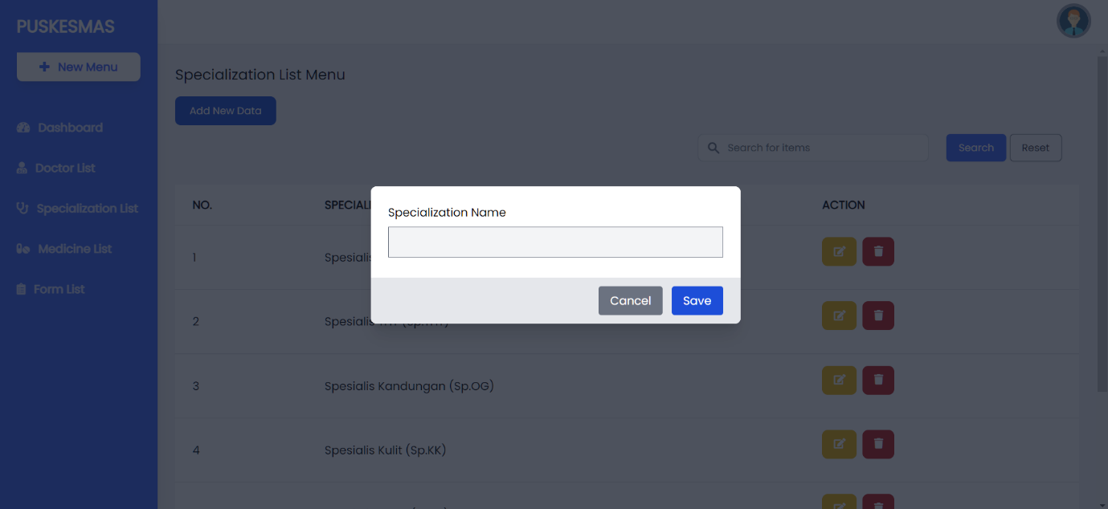

1. Frontpage

Landing page display for Frontpage

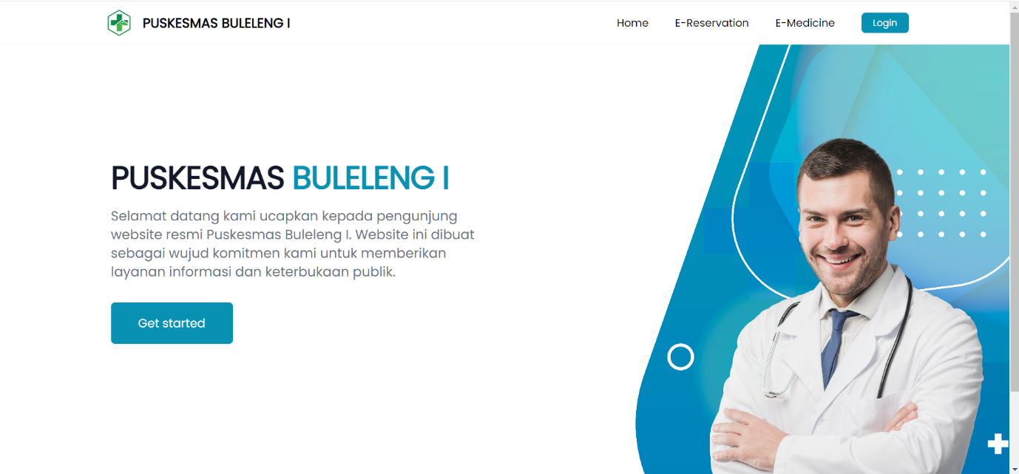

Display when the user clicks on E-Medicine

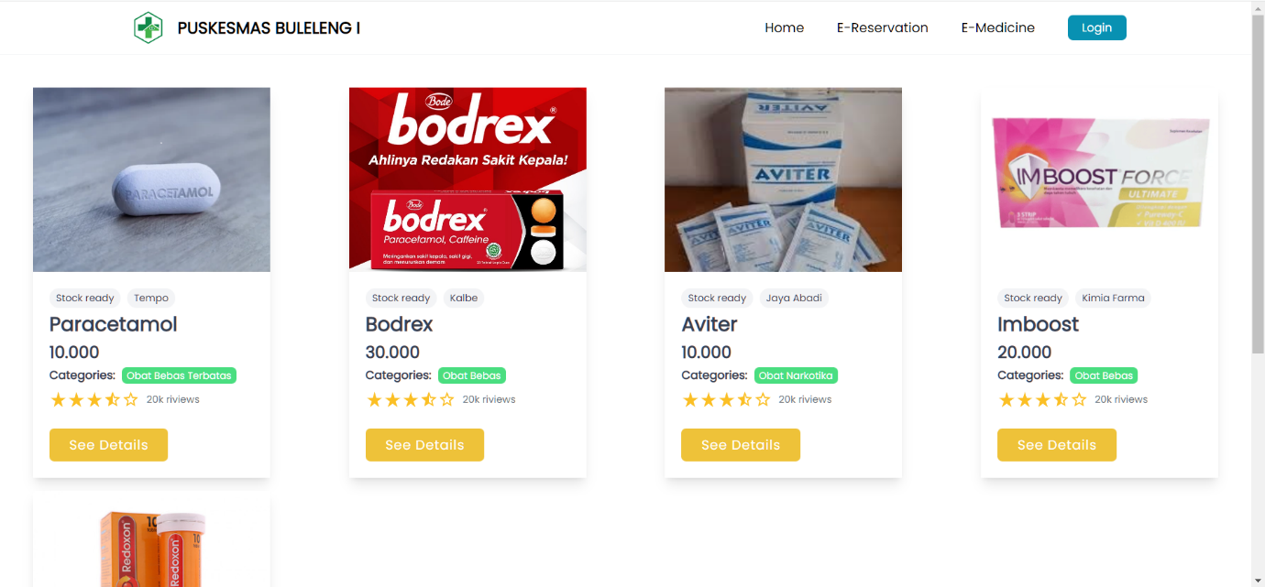

Display when clicking product details.

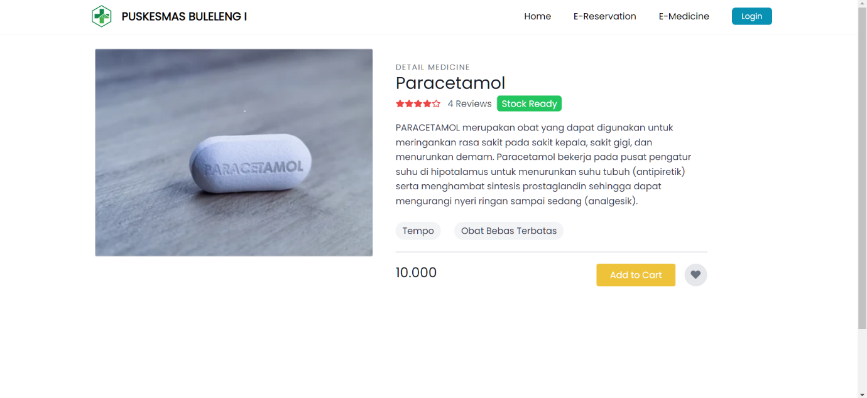

View when user Click Add to Cart.

View a list of existing doctors.

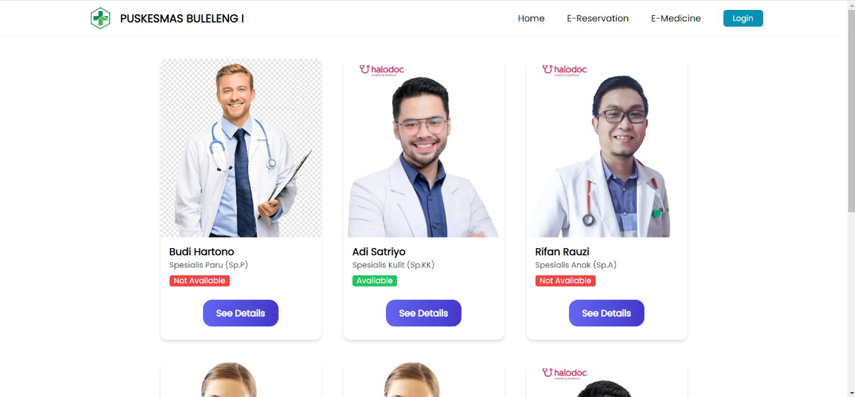Doctor detail view

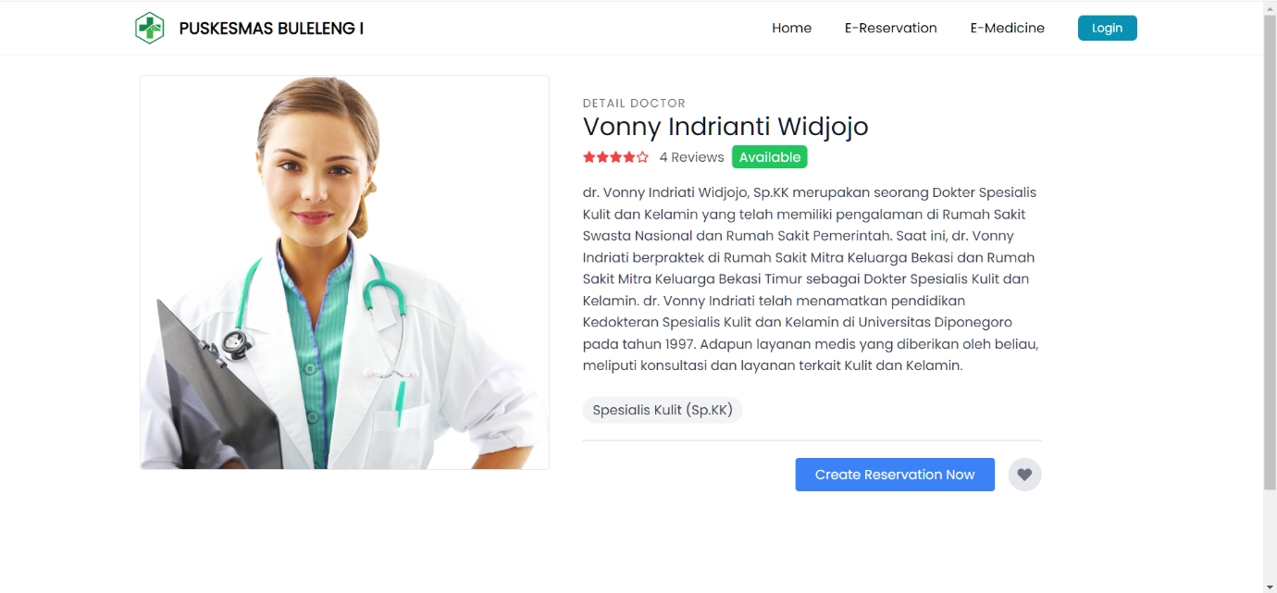

Display when the user wants to make a reservation or consult a doctor.

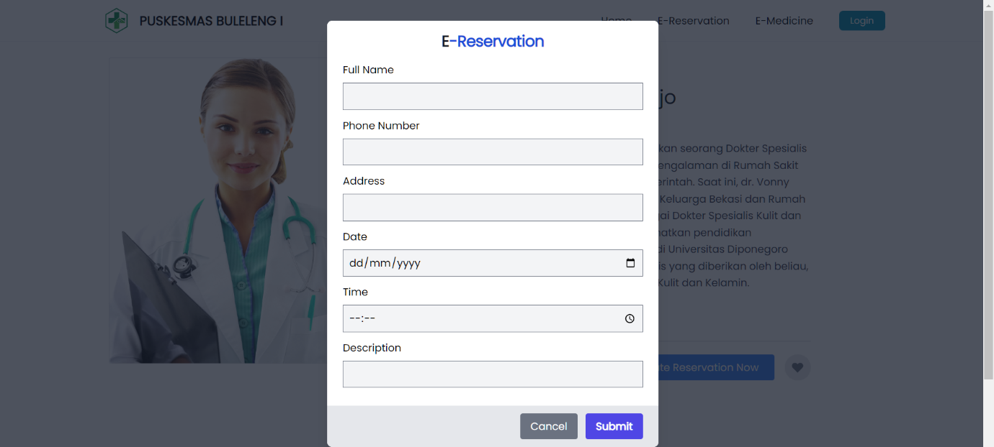

From the use case and display design of the website that has been described above, an ERD can be made for the database which will be used later to process data on the website later as follows:

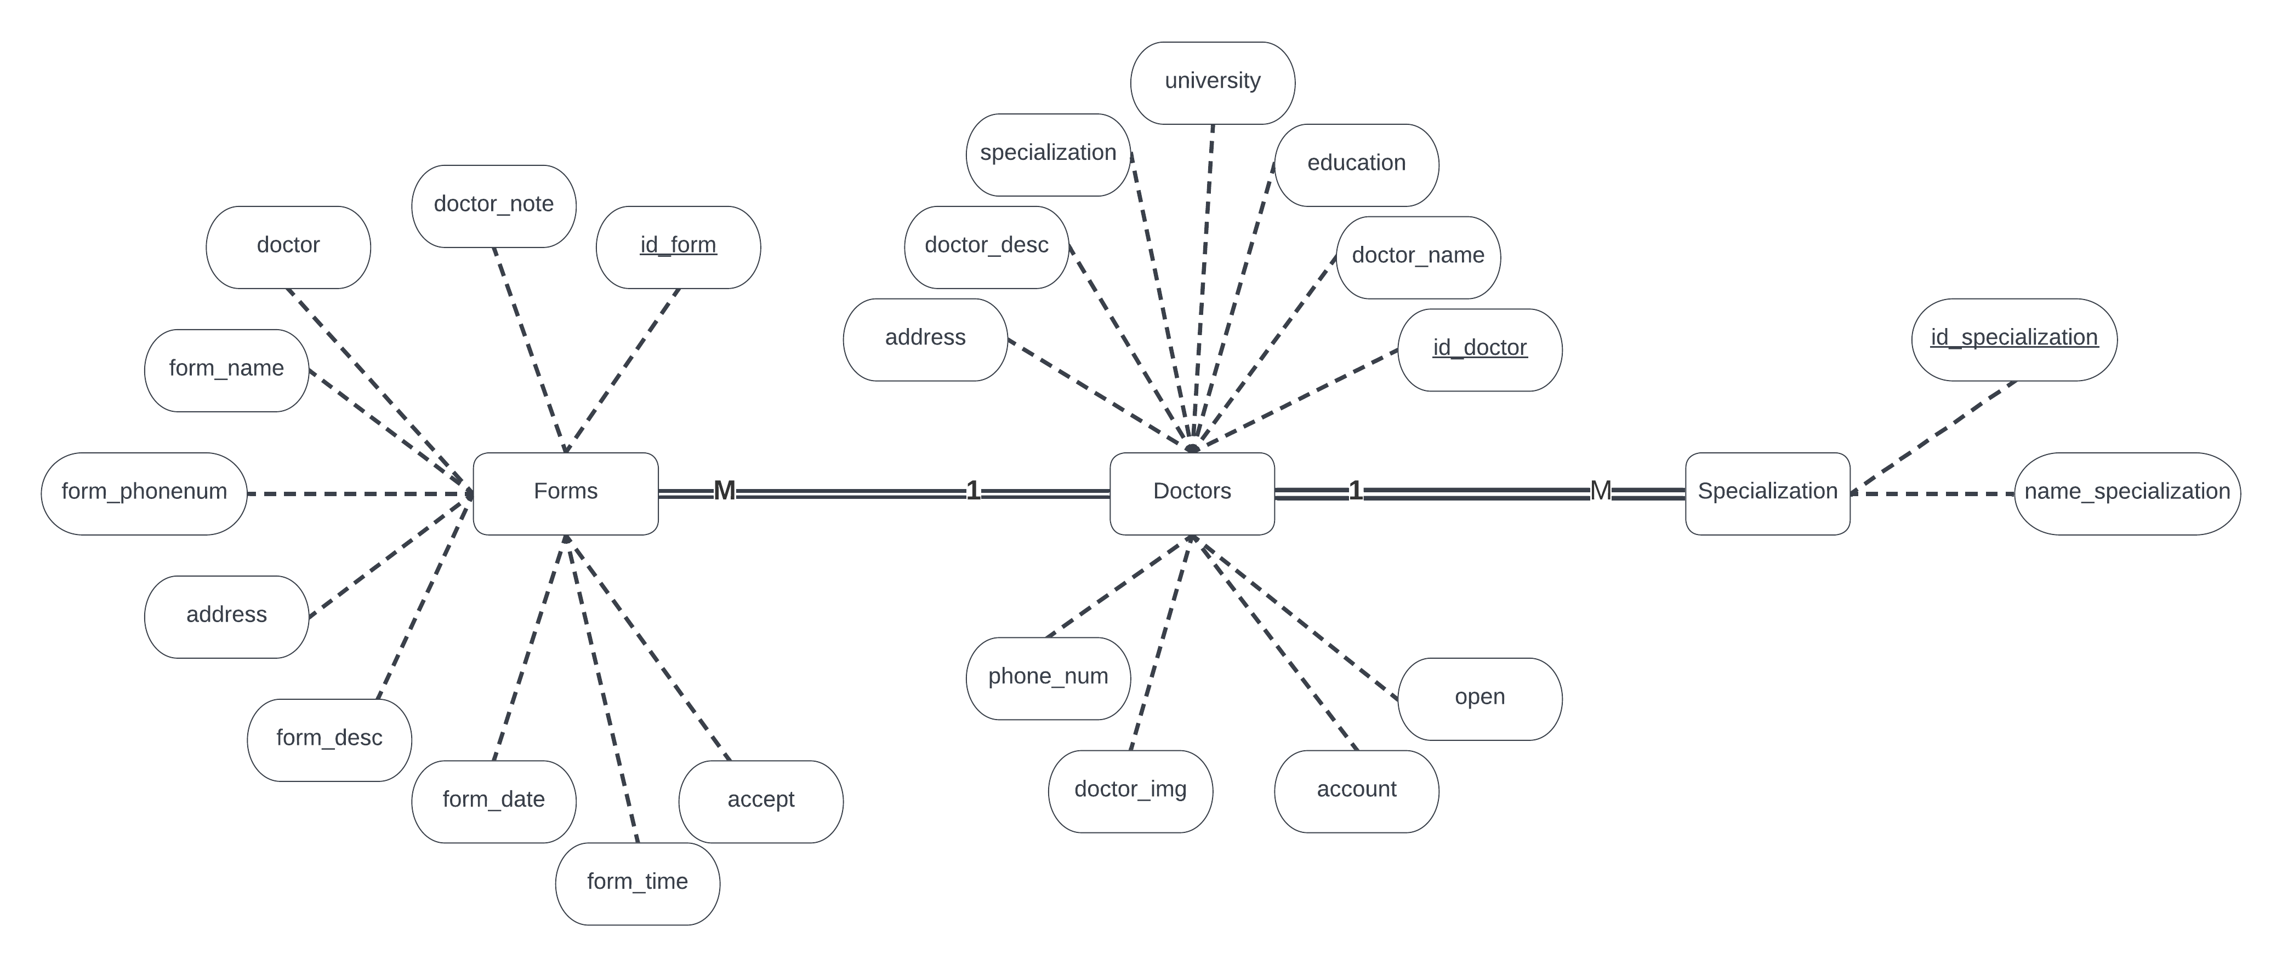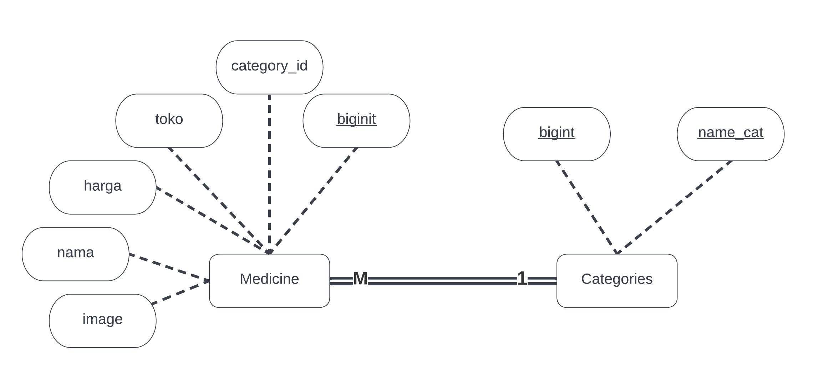

* 1. **Implementation**

From the plan that has been explained previously in the implementation of the program itself, the following results are obtained:

1. Backpage

* View list of doctors.

In this view the admin can see related data from doctors registered in the application where the admin can edit, delete or add doctors to existing data by using the icon on the display. In addition, there is also a search feature to make it easier to find the doctor data you want.



* Add new list of doctors

This page will appear when the admin clicks add data on the Doctor list page where on this page a doctor's data is created which will appear on the frontpage page later.



* Display medicine list

The Medicine List contains a list of medicines that can be purchased by the user which is the same as the doctor list on this page, the admin can also do CRUD by clicking on the icons on the medicine list page.



* Add new drug data display

On this page the admin adds data for drugs that can be purchased by the user.



* Display form list user

On this page the admin and doctor can see the consultation agreement made by the public user, where there is also a status of whether the doctor agrees or disagrees with the existing consultation agreement. On this page you can also see whether the doctor has confirmed it or not.



* Display edits form list user

On this page the admin and doctor can see the details of the consultation agreement made by the user with the doctor.



* Display specialization doctor list

This page displays any existing specializations or specializations of all registered players in the system.



* Confirmation edit and create specialization doctor

Display where there are additions or changes related to existing specializations in the system.



1. Frontpage

* Landing page display for Frontpage

This page contains a brief description of the website that the user will access.



* Display when the user clicks on E-Medicine

Contains a list of medicines that can be purchased by the user where the user can also see the details of the drug first or buy it directly.



* Display when clicking drug details.

Displays details of the drug which contains the benefits and uses of the drug itself and there is also a description of whether the drug is available or not.



* Display when user clicking add to cart button.

This page contains products that have been added to the cart, along with the total price of all the items there. Users can make payments by clicking the “Checkout“ button

* View a list of existing doctors.

Contains a list of doctors registered in the system where there is also the status of whether the doctor exists or not.



* List detail’s view

A page that displays the details of a doctor, giving details of his specialty, educational history and also the institution where he currently works.



* Display when the user wants to make a reservation or consult a doctor.

This is a page where the user will make an agreement with the doctor to consult with him where the user will fill in some data that the doctor will also need later.



**CHAPTER III**

**CONCLUSION**

From this project, there are several main features that you can make, namely in the form of front pages and back pages that function so that data can be received by users via the front page and data can be processed via the back page. On this website, on the frontpage, users can see a list of drugs and doctors registered in the system. In addition, users can see details of existing drugs and doctors. At the doctor himself, the user can make a consultation appointment with the doctor he chooses. However, the display showing whether the agreement was approved by the doctor has not been made yet so the user cannot see whether the agreement can be made or not. Then the lack of features on the frontpage is that there are no search or filter features.

Meanwhile, on the back page itself, the existing features are quite complete, where there is a list of drugs, a list of doctors, a list of user-made agreements and a list of specialists in the system, and all the things previously stated already have CRUD in it. There are also search and filter features in this back page section.

A feature that is lacking from the website that we made is also that there is no multi-user or division of roles for logged-in users. And there is also no data base table that can later accommodate data from drug purchases made by users later so it is necessary to make tables and pages for the future so that the main features that we want to bring on this website will be completed.